EXP 08

**Create a simple cloud web application for student counselling system using any Cloud Service Provider to demonstrate SaaS with the fields of student name, age, address, phone, subjects studied, Year of passing, percentage of marks, domain interest, etc**

STEP 1: Sign in to the zoho.com and click the creator option

STEP 2: After enter into the creator click the create solution

R.Akash 192121091

STEP 3: To create the application by select the application

STEP 4: After selection the application to create the new component form

R.Akash 192121091

STEP 5: Click and open the scratch from the form

STEP 6: Enter the name of the form to crate the form

R.Akash 192121091

STEP 7: choose any form of template to create the page form

STEP 8: To create the form pages of the application by basic fields

R.Akash 192121091

STEP 9: The first form to create the Student details

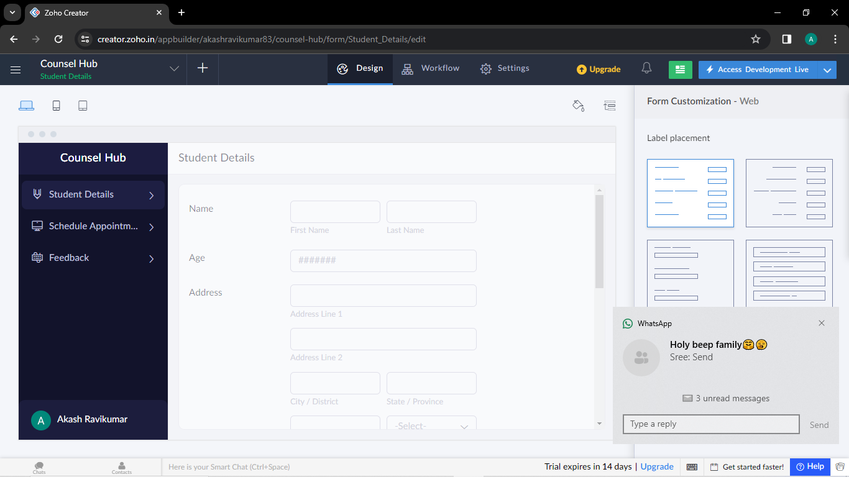

STEP 10: The second form to create the schedule appointment

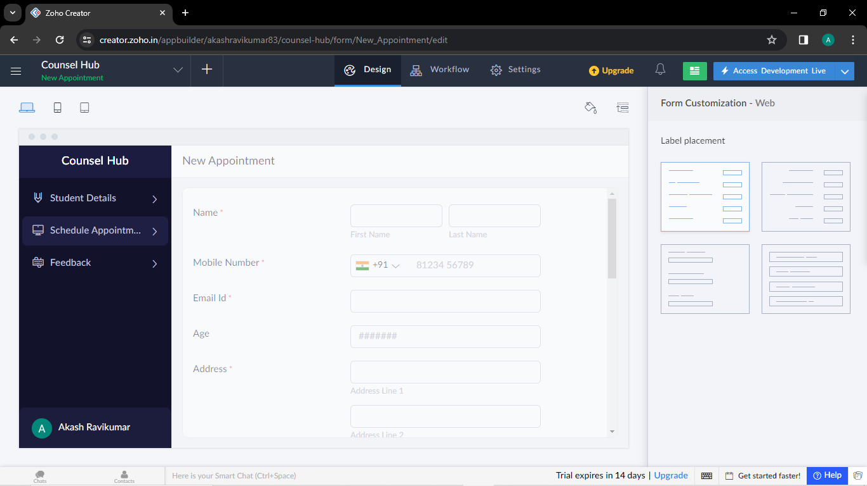

R.Akash 192121091

STEP 11: The third form is to create the feedback form

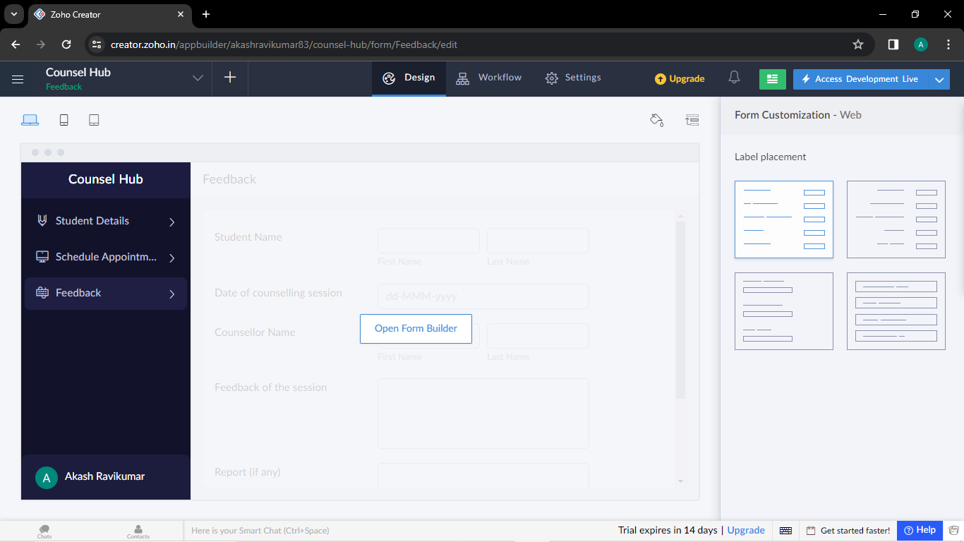

R.Akash 192121091